LAB ACTION WEEK 6
23BD1A663B
1.Define and run multiple interdependent services
Task:
- Create a new folder compose-lab
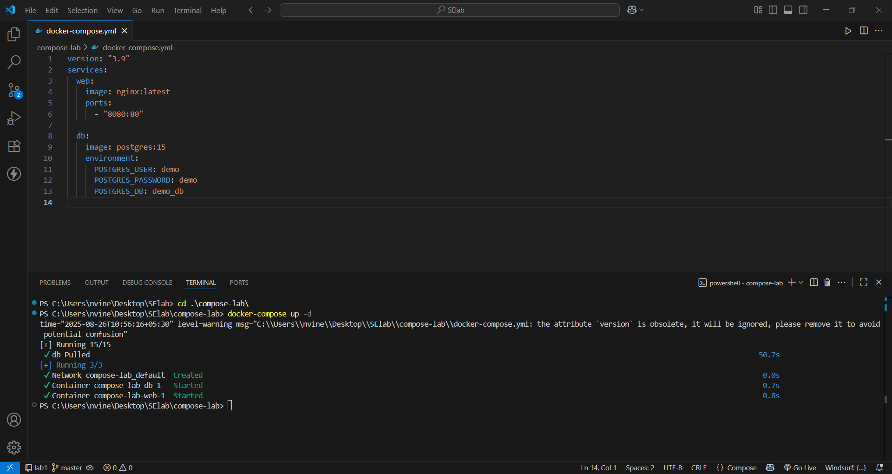
II. Run the setup:
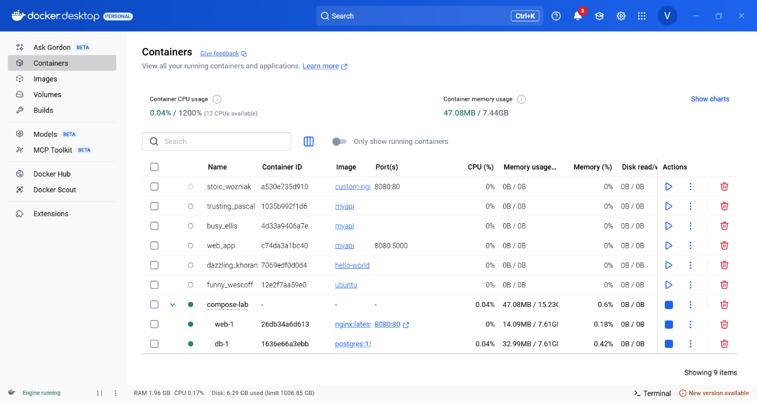
docker compose up -d

III. Open your browser and visit: http://localhost:8080.
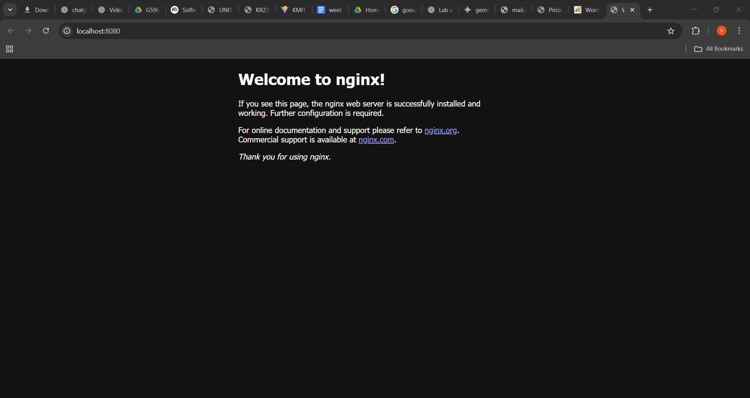
IV. Expected Output:

Nginx welcome page is displayed.
db container runs in the background.

2.Write and interpret docker-compose.yml files
Task:
- Modify docker-compose.yml to add a Redis cache:
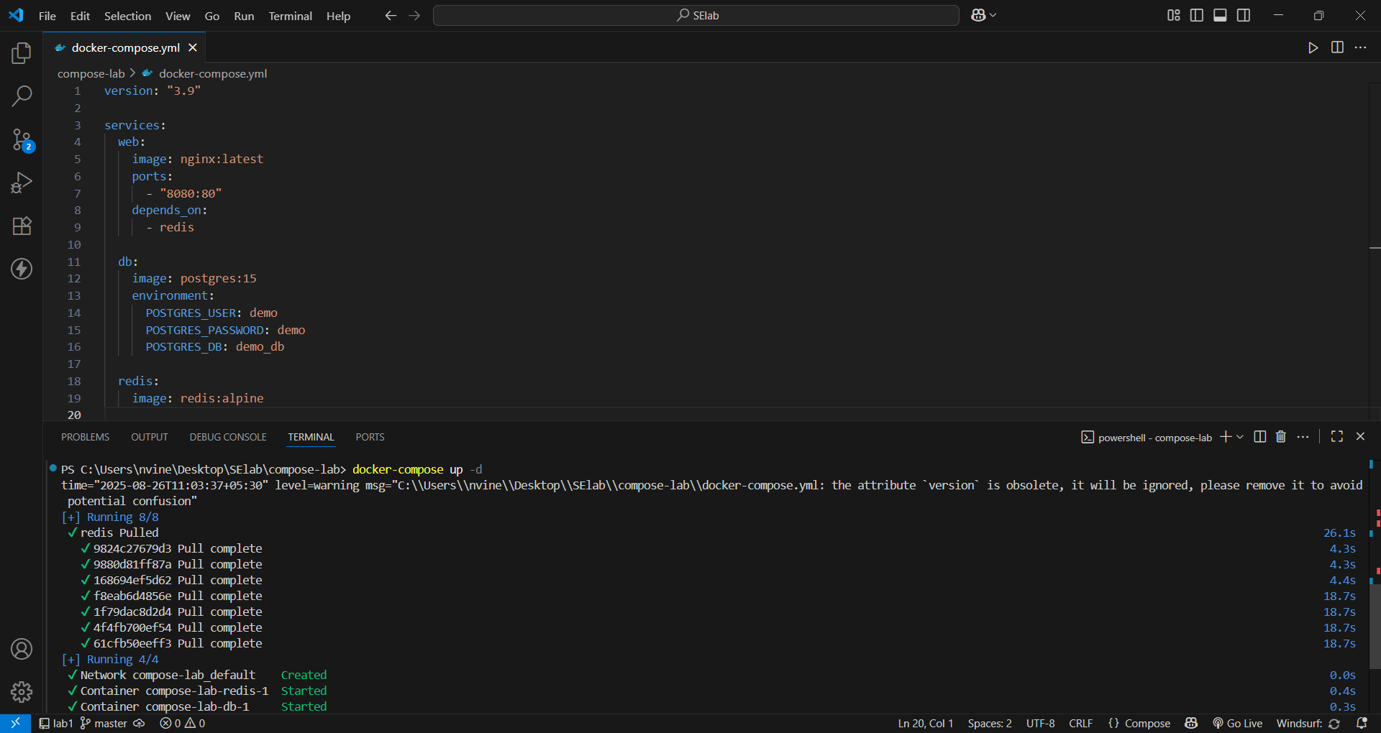
II. Add a depends_on so web waits for Redis:
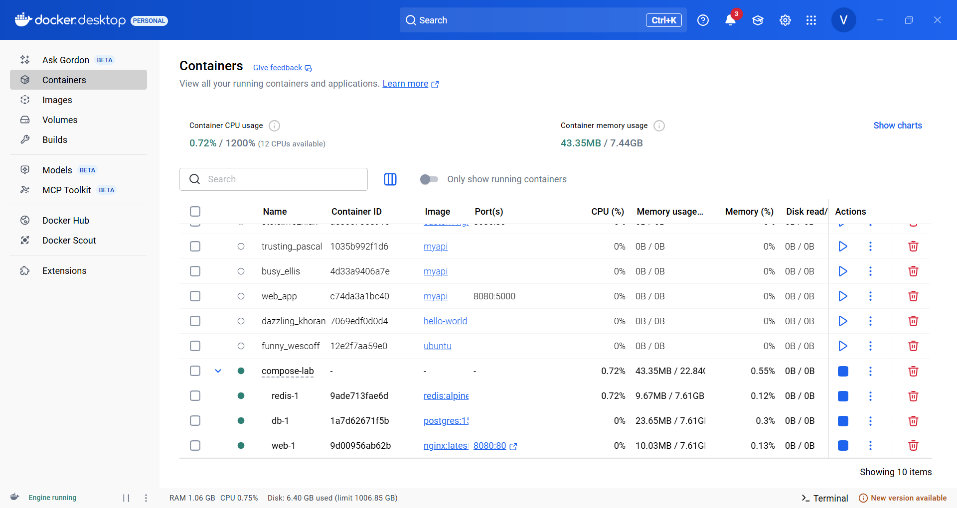
III. Restart the setup:
docker compose up -d
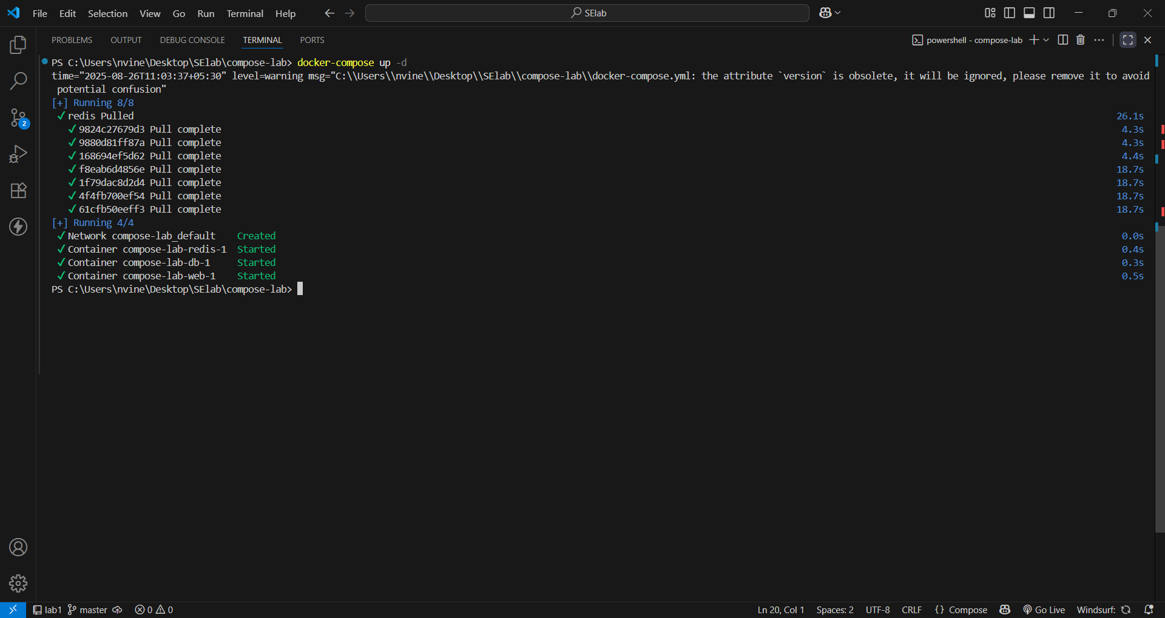
docker compose ps
IV. Expected Output:

Three services (web, db, redis) are listed as running.

3.Deploy across different machines
Task:
- Zip your compose-lab folder.

Transfer it to another machine with Docker Compose installed.
II. Run:
docker compose up -d
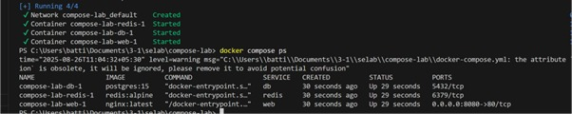
Check that Nginx and Postgres work there as well.

III. Expected Output:
The same services run on the new machine without changes.
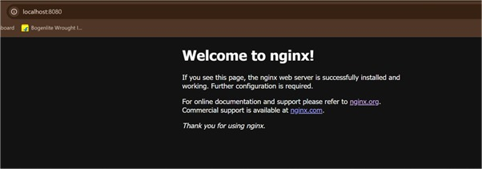

4.Networking and persistent storage
Task:
- Update your docker-compose.yml to add a custom network and volume:
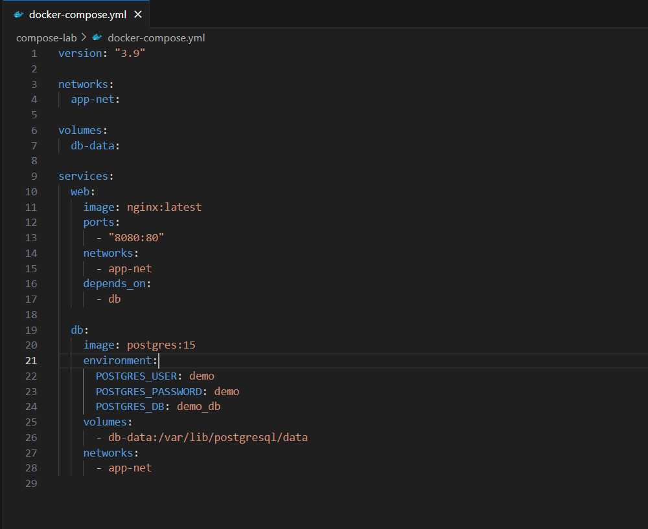
II. Run:
docker compose up -d
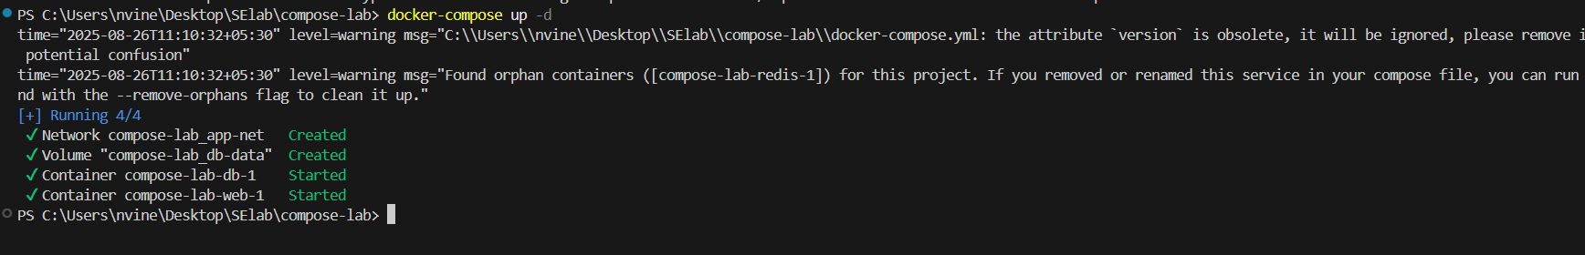
III. Insert some data into Postgres (optional with psql).

IV. Remove containers:
docker compose down
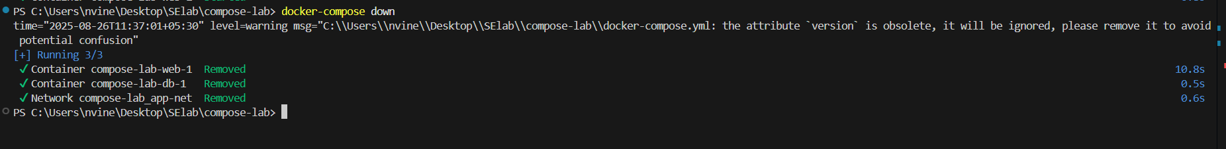,

V. Start again:
docker compose up -d
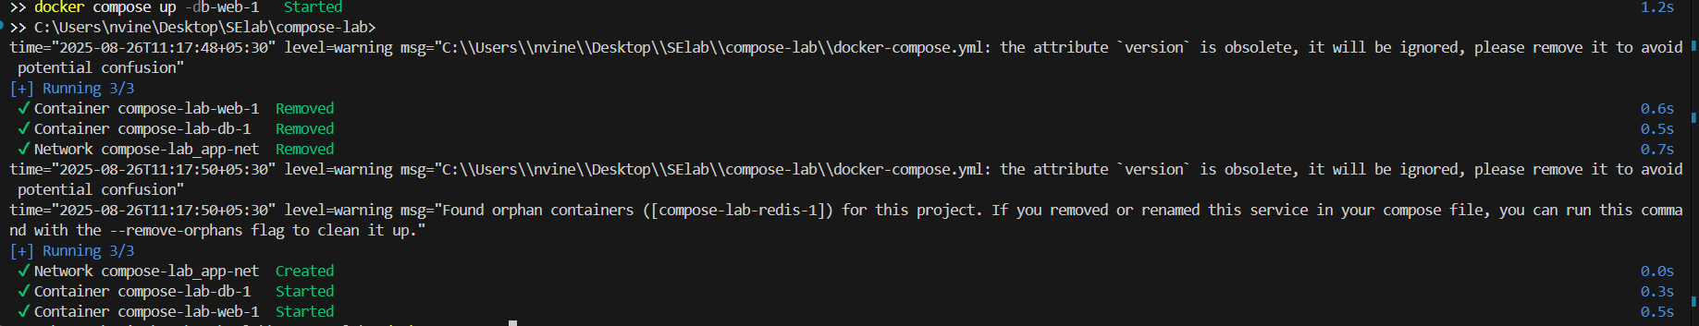

VI. Expected Output:
Database data persists across restarts.
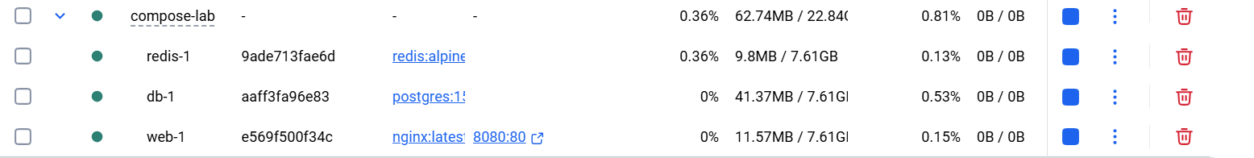
Services communicate via the app-net network using service names.

5.Faster iteration during development
Task:
- Create a simple Flask app in app.py:
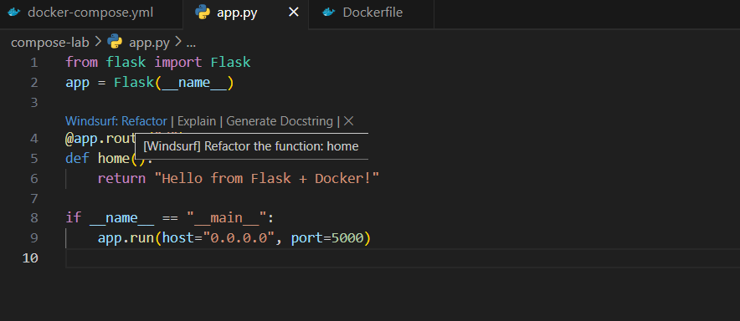
II. Add a Dockerfile in the same folder:
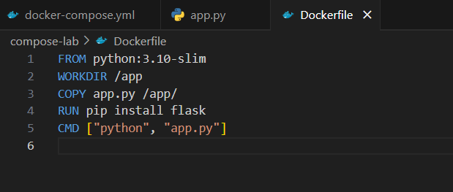
III. Update docker-compose.yml:
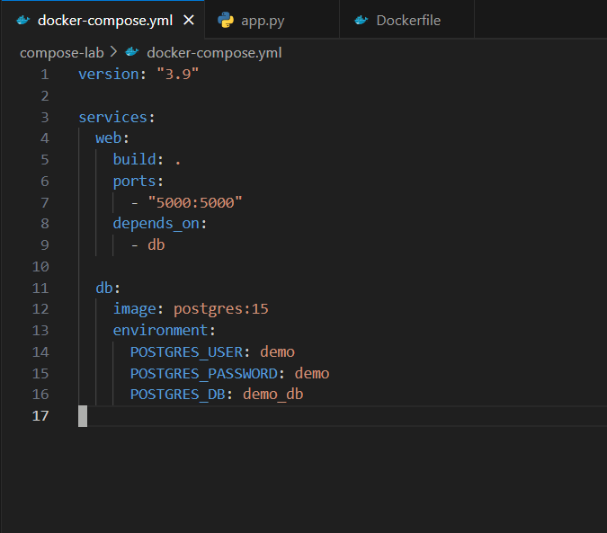
IV. Run:
docker compose up –build
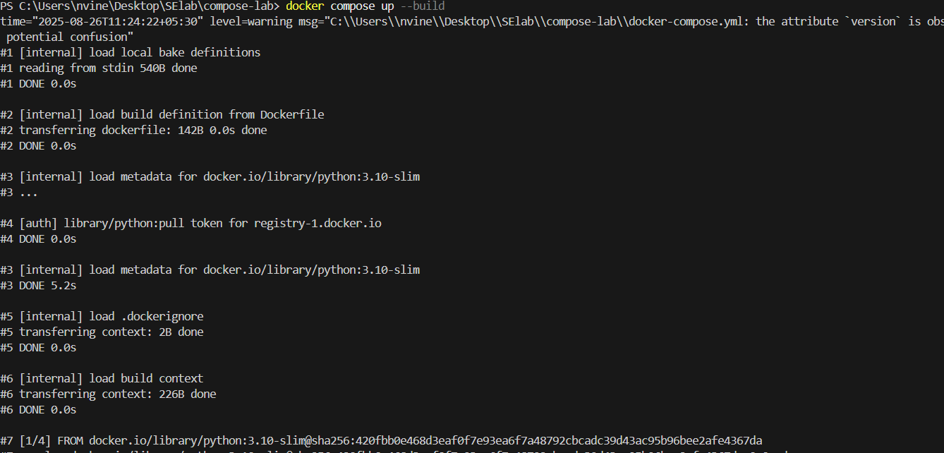
…
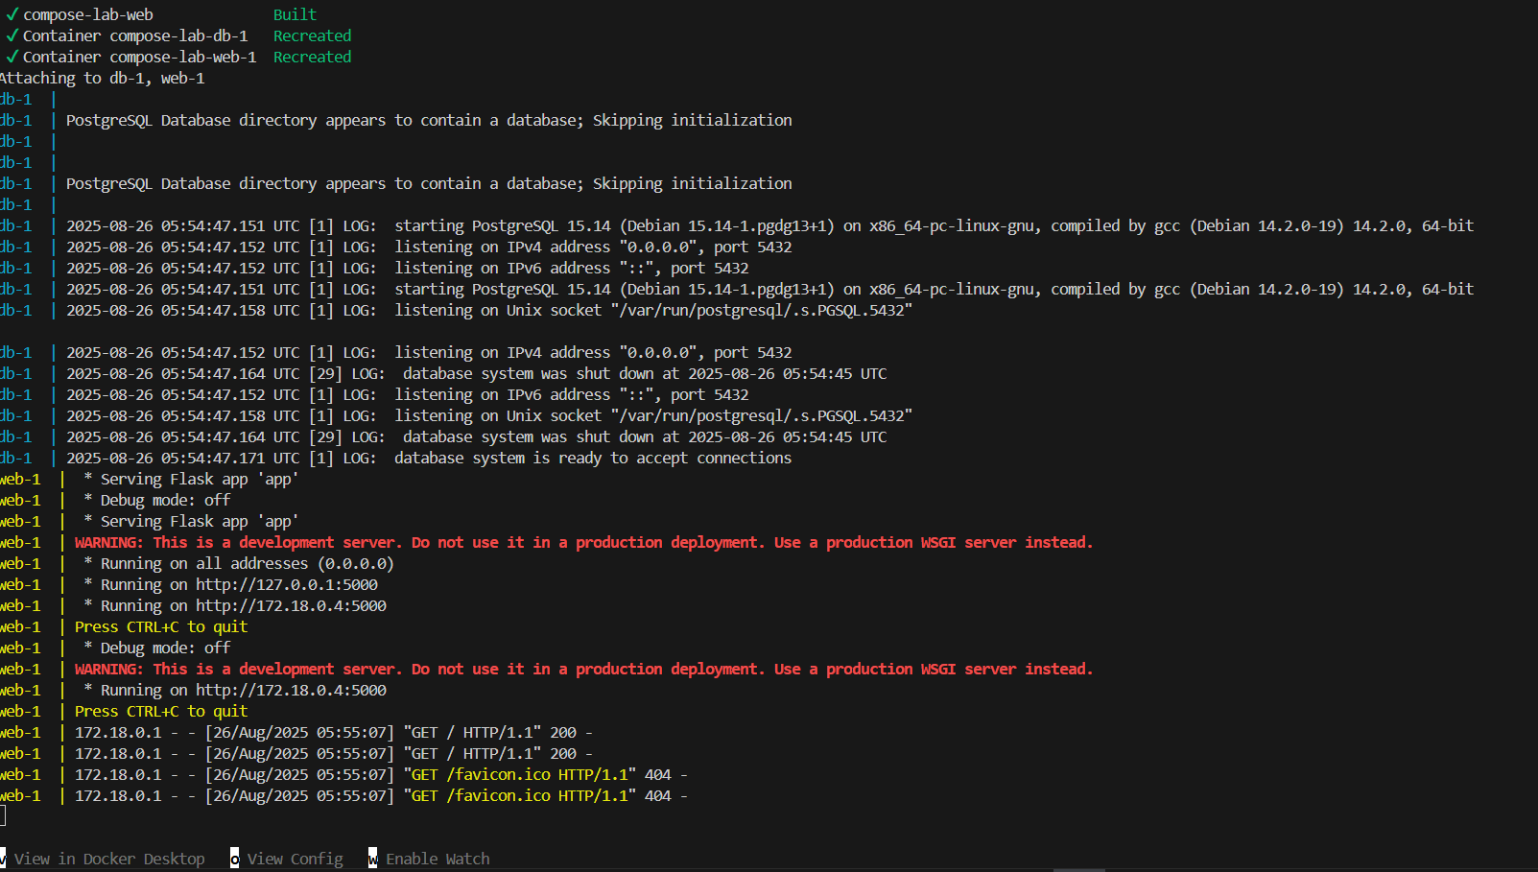
Visit http://localhost:5000.
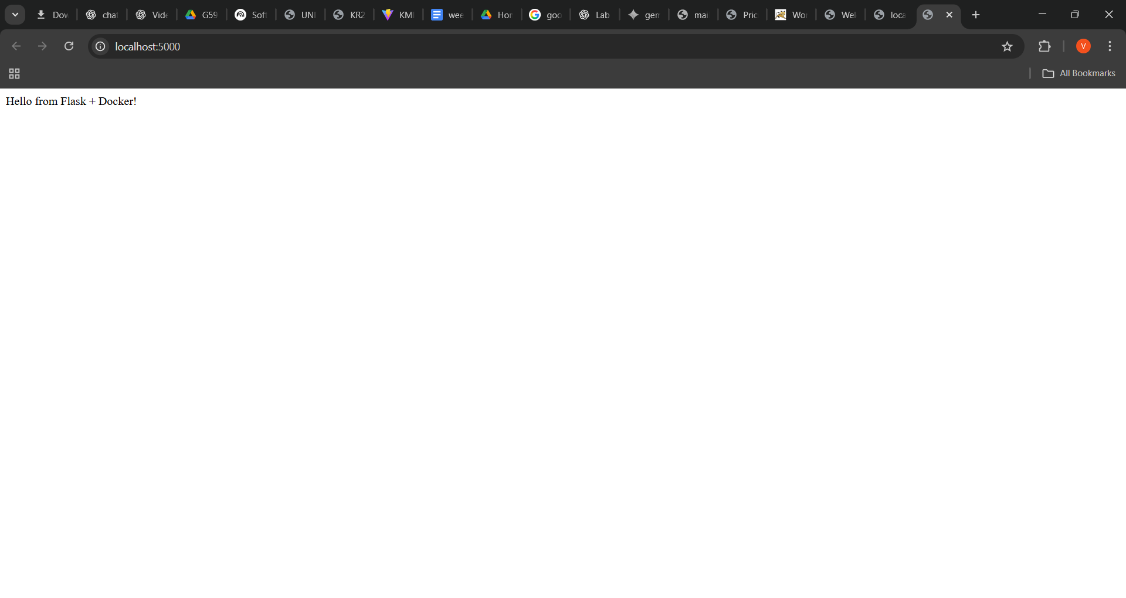
Change the return text in app.py (e.g., "Hello Docker Compose!").
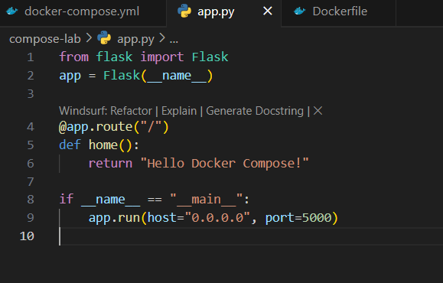
V. Rebuild:
docker compose up –build
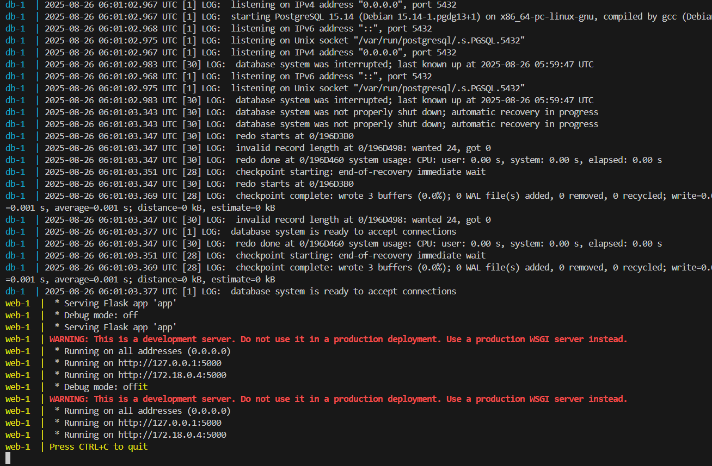
VI. Expected Output:
New message appears instantly after rebuild.
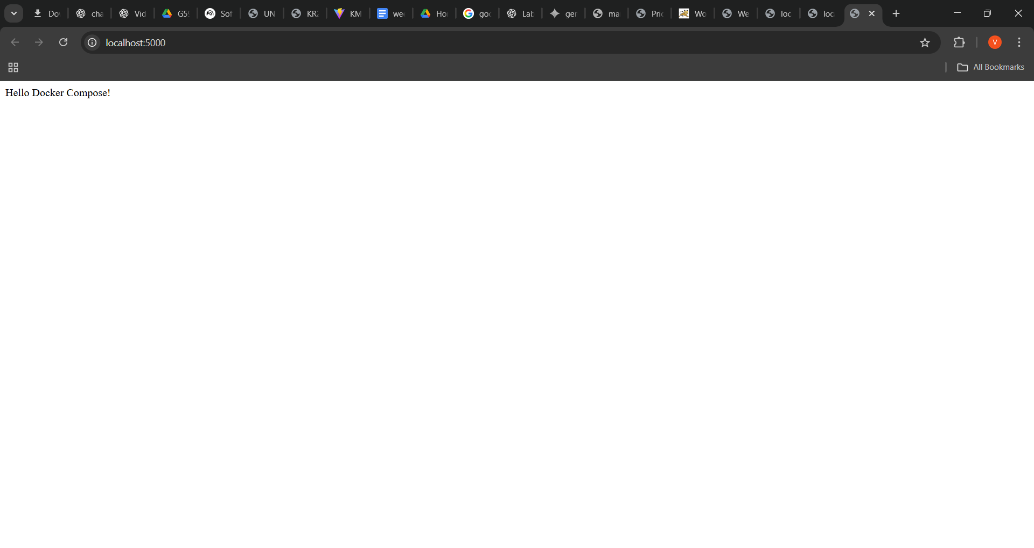

Scenario based Questions:
1. You have two applications — a Node.js backend and a Python script that handles scheduled jobs. You're considering running both inside the same container. Should you run multiple applications in the same Docker container?
2. You have a Flask API and an Nginx server. You want to run both containers on the same host and expose them on ports 5000 and 80 respectively. How can you expose both applications from different containers?
3. You want to run a React frontend, an Express.js backend and MongoDB – all together.
How do you run and manage all three together?
4. You try to run two containers that both expose port 8080 on the host.
What happens, and how can you run both apps?
5. You updated some code and want to restart your frontend, backend, and DB containers quickly. What is the easiest way to restart all services?
6. Your frontend has a new release, but you don’t want to restart the backend or DB.
How can you update and rebuild only the frontend container?
7. Tomcat is listening on port 8080, but you get a "Connection Refused" error in the browser. Why?
8. You're not sure which container is using port 3000. How do you check?
9. How do you stop and clean up your running Tomcat container and image?
10.You want to share your app with a teammate. What do you do with the Docker image?

Conclusion:
Docker Compose simplifies multi-container application management by allowing developers to define, configure, and run services in a single YAML file. It streamlines deployment, ensures consistent environments, and reduces manual setup, making it an essential tool for orchestrating complex, container-based applications efficiently.

